# **CAREFORALL Media Campaign**

* Teaser video (Coming Soon for CFA)
* CFA Announcement Poster (Coming Soon)
* CFA Event Cover (Coming Soon)
* CFA Cover for Facebook (Coming Soon)
* Throwback Speakers (Same template):

1. Raheela Tariq
2. Iftikhar Mubarik
3. Komal Nagi
4. Atif Adnan
5. Khalid Zaheer
6. Azhar Hamza
7. Umair Jaliawala
8. Faisal Akbar Awan
9. Sabir Arif
10. Jibran Nasir
11. Ali Hamza

* CFA Announcement Poster (With DATE & TIME) === 3D Graphic
* CFA Event Cover (With DATE & TIME)
* CFA Cover for Facebook (With DATE & TIME)
* Women’s Rights Announcement Post === 3D Graphic
* Women’s Rights Documentary
* Documentary Competition (Announcement + Rules)
* Incentives for Documentary Competition
* Deadline for Competition
* Winners Announcement for Documentary Competition
* CFA Team Pictures Templates
* Teaser video for concert (Guess the band)
* Concert Announcement
* CFA Speakers Template (Different from Throwback Template)

1. Nighat Dad
2. Salman Sufi
3. Khadija Brohi
4. Khadija Siddique
5. Ali Ahmad Awan
6. Taimur Rehman
7. Ambreen Waheed

Note: Description for speakers will be provided soon but keep the template ready

* Posts for Women Rights to encourage people (** check below)
* Countdown Posts till CareForAll (Start from 5 days to go)

Examples of Posts for Women Rights to encourage people (** check below)

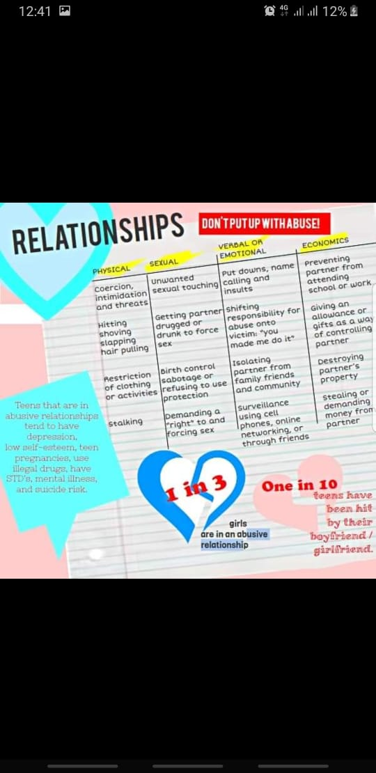

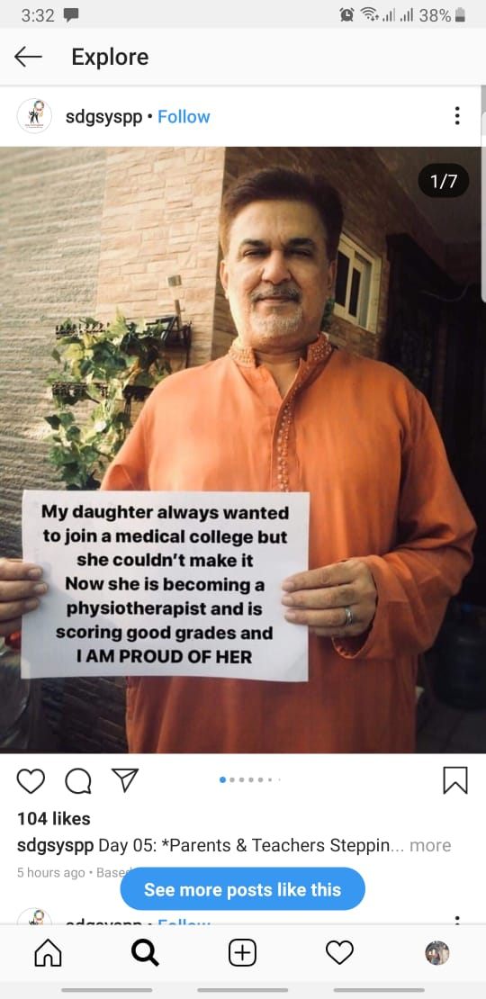

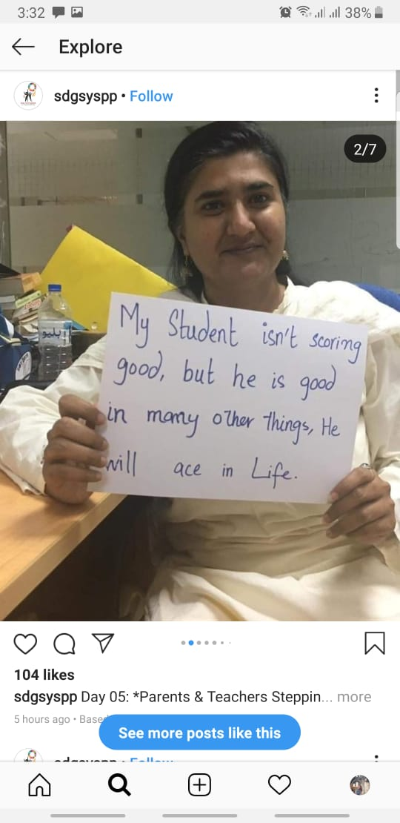

Template for this will be for women rights. People from FASTCare will hold placards in support of women emporement.

